**UI DESIGNS FOR MEDIPAL**

1. **Login/Register screen**

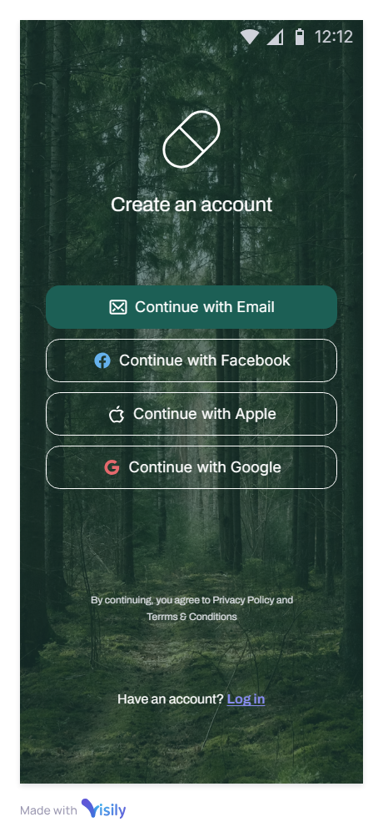

* When the user first opens up the app, this will be the first screen that they see.
* Here the user can choose to either register by using their email and creating a password, or log in via their email and password if they have already made an account before.

1. **Home screen**

* **Main screen:**

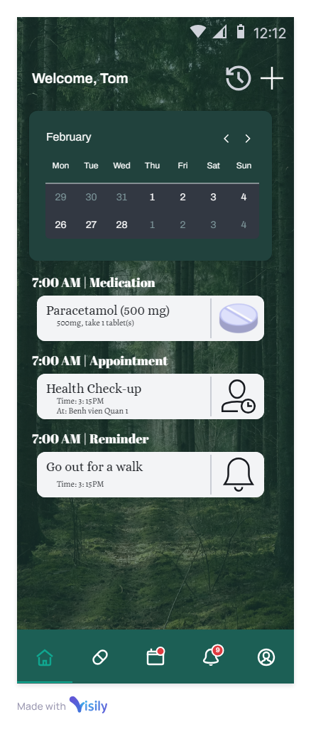

* After registering or logging in, the user will be presented with the home screen of MediPal.
* This screen mainly features a calendar where you can select a particular date to see reminders set for that selected date. Below the calendar is a list of reminders that are scheduled for the current date.
* In the top right, the user can see the history log of all past medication, appointment and health care reminders by pressing the clock button, or adding a medication, appointment or healthcare reminder by pressing the plus button.
* At the bottom, the user can navigate through the application via multiple symbolized buttons in the tab. Besides the home button, the user can see the medications list, the appointment list, a miscellaneous reminder list and user profile.
* **Add new medication/appointment/reminder:**

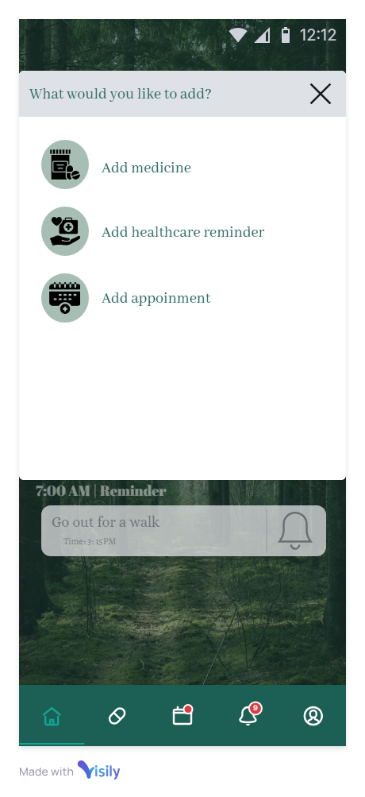

* Upon clicking the plus button in the main screen, a pop up will appear asking what type of reminder the user would like to add to their list. Clicking one of these buttons will take the user to its respective customization screen.
* **History log:**

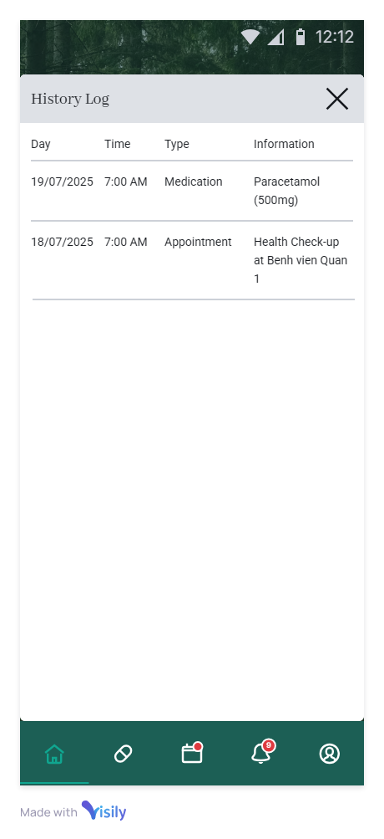

* If the user clicks the clock icon in the home screen, the user will be presented with the history log, where the user can see reminders that have occurred in the past.

1. **Medications**

* **Medication list:**

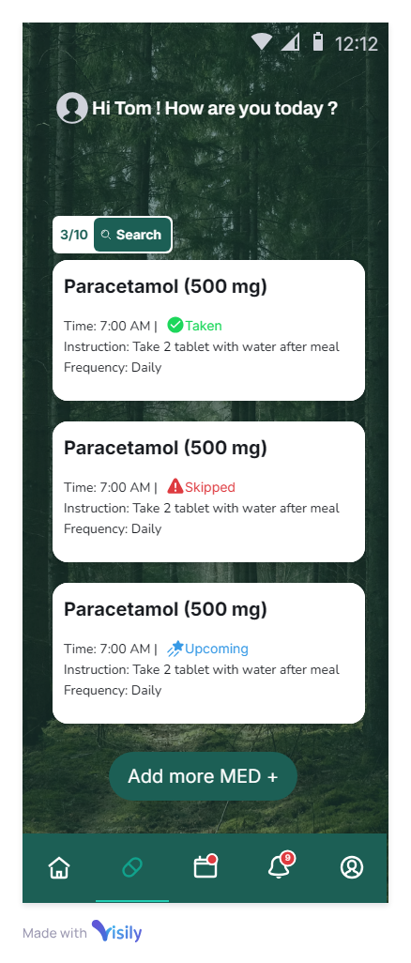

* Upon clicking on the medication list icon in the bottom tab, the user will see a list of medication reminders, displaying information such as medication names, their respective dosages, how often the medication should be taken.
* Above the list there is a search button that allows the user to search for a medication reminder by their name, and near the bottom there is a button for adding a new medication reminder.
* **Add new medication:**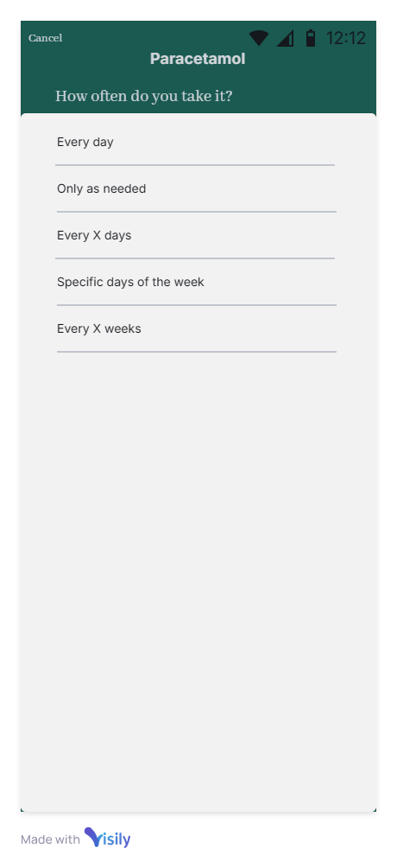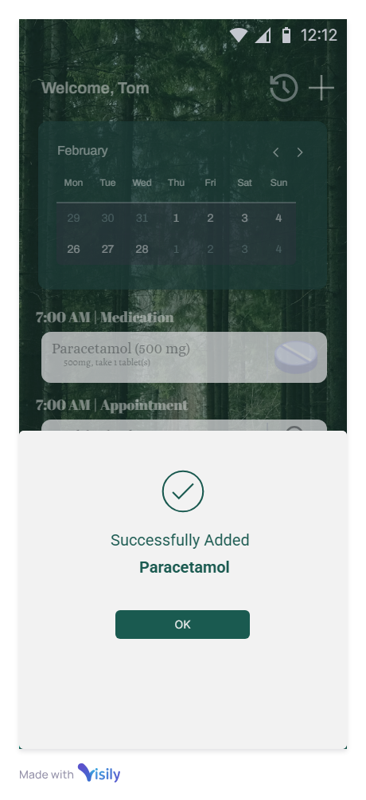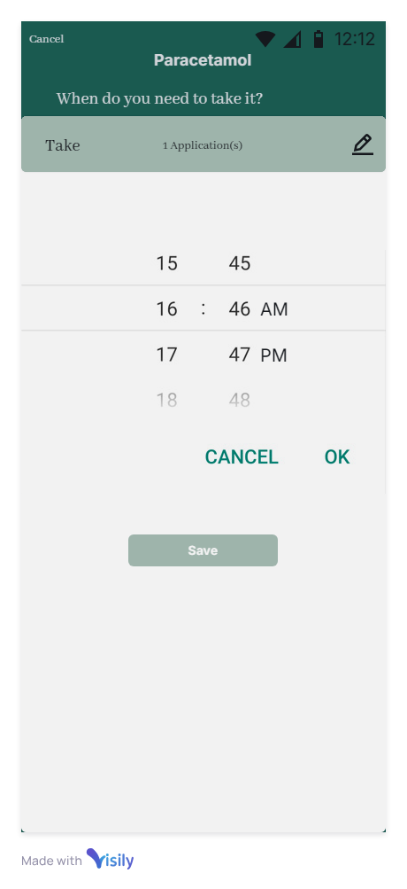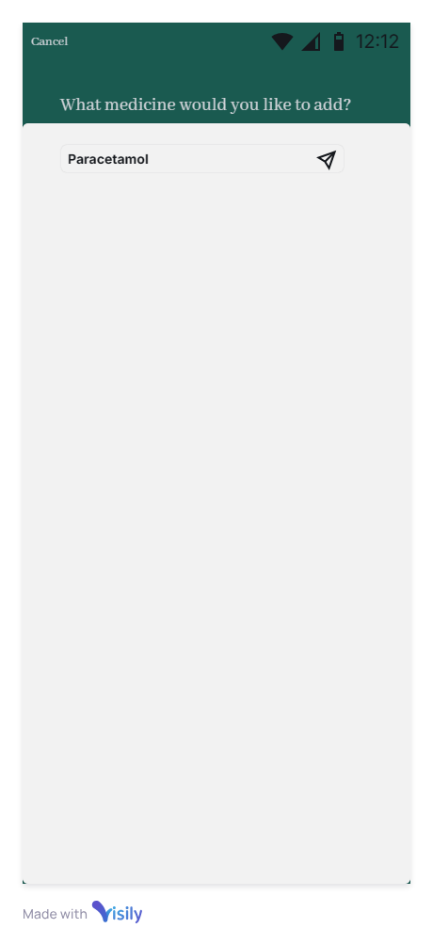
* If the user chooses to add a new medication, a pop-up will appear to ask for the user’s input for the medication name first.
* Then, the user can set how often the medication should be taken as well as the time of day that the reminder should notify the user.
* After having added all the necessary information, a pop-up showing a successful addition of a new medication will be presented.
* **Editing a medication:**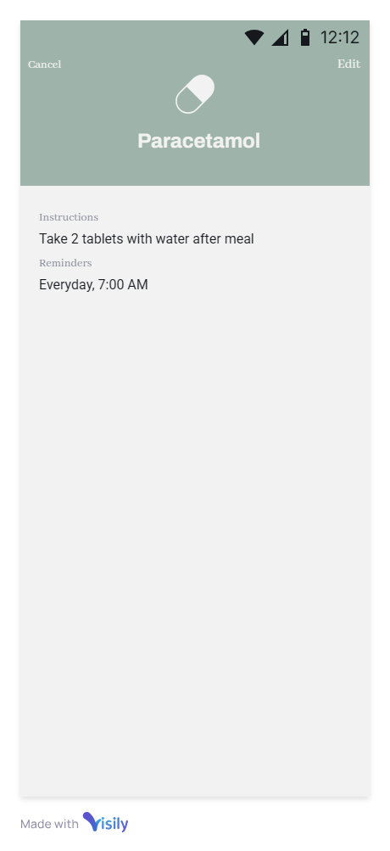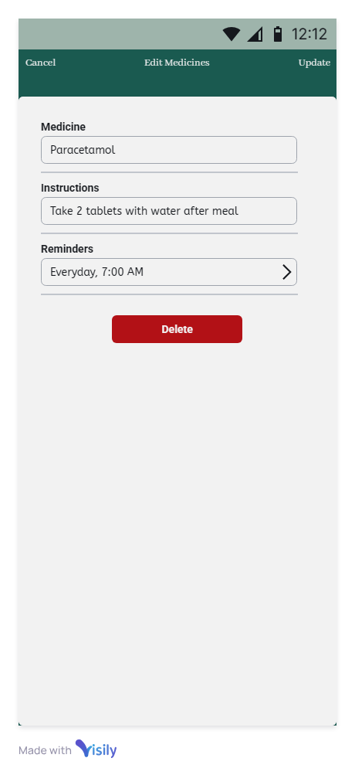
* If the user chooses an item from the medication list, information related to that particular item will be presented, where the user can now choose to edit the medication reminder information.
* If chosen to edit, the user can edit the name, frequency and time of the medication item or delete the item altogether from the list.
* **Searching for a medication:**

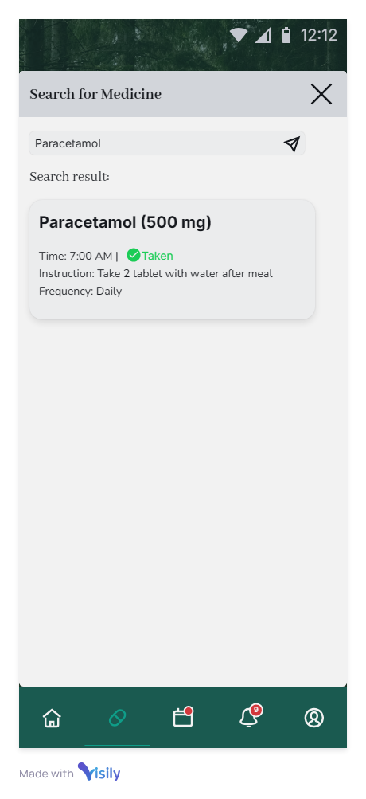

* If the user chooses to search for a medication, the user will have to type a medication name into the search bar to be presented with a list of all items that match with the queried name.

1. **Appointments & Healthcare Reminders**

* **List of items:**

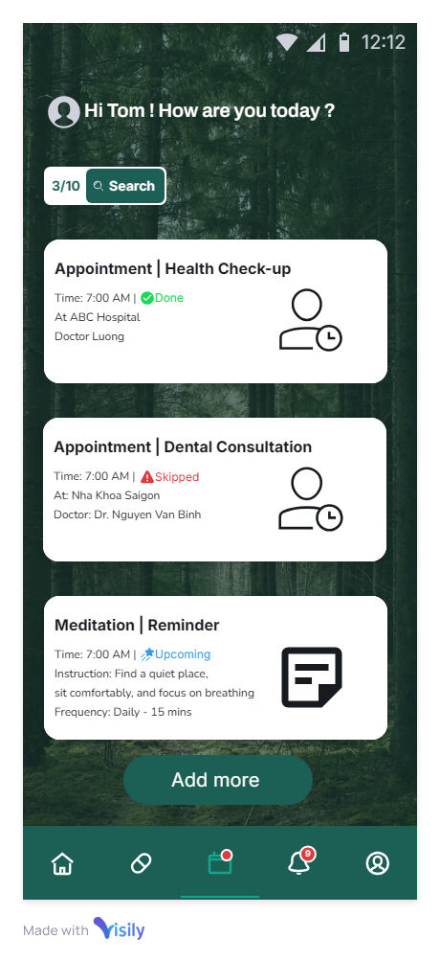

* Upon clicking on the calendar icon in the bottom tab, the user will see a list of appointment and healthcare reminders, displaying their respective information. In this screen, there will also be options to add more appointments or edit existing ones.
* If the user clicks an item, the user will see more specific information related to that reminder as well as being able to choose between 3 options - “Skip”, “Un-taken” or “Snooze”:

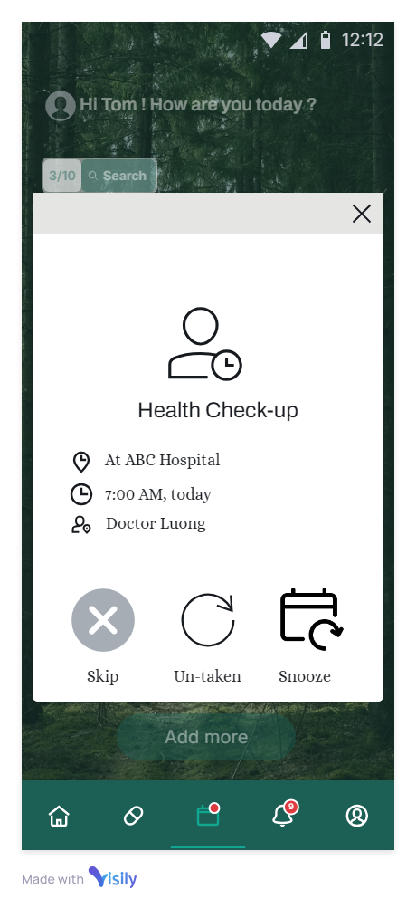

* **Add appointment/healthcare reminder:**

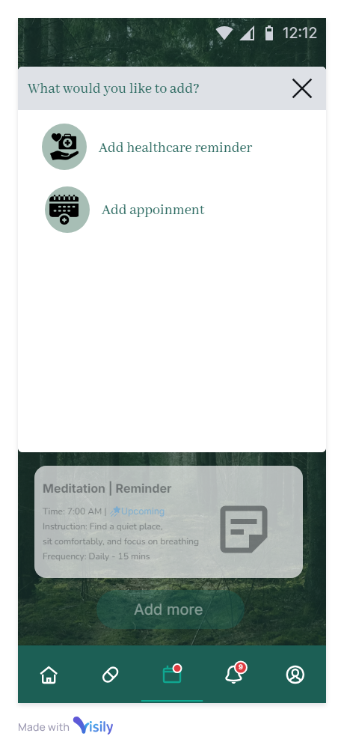

* If the user chooses to add more, a pop-up will ask the user to choose which type of reminder to ask
* **Add healthcare reminder:**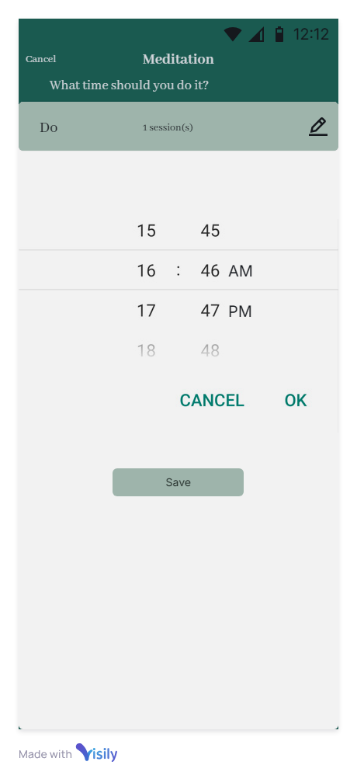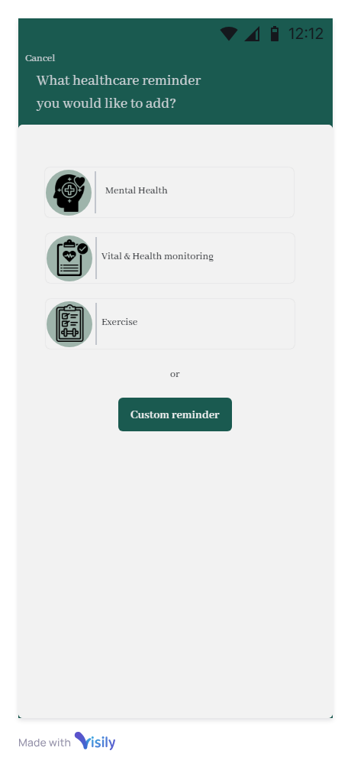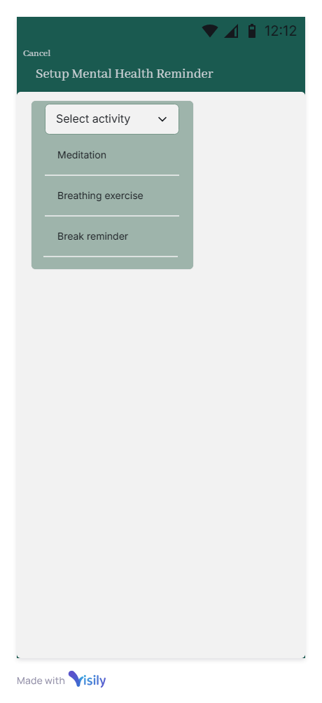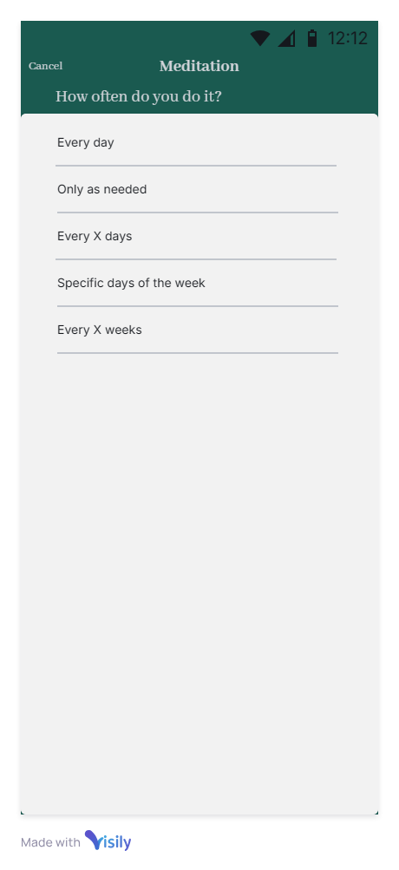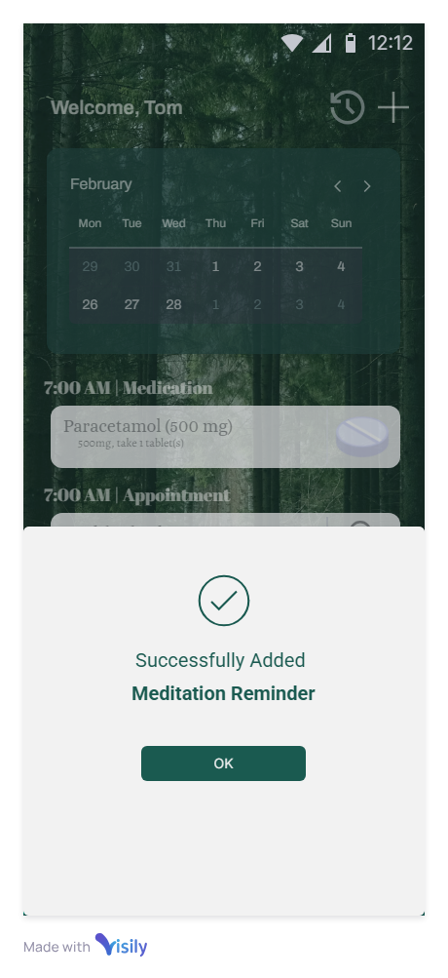

* If the user chooses to add a healthcare reminder, the user will first have to pick a type of healthcare reminder to add or choose to make a custom reminder.
* Then, the user can select an activity from a drop-down list. After that, the user can select the frequency as well as the time the activity should be done.
* After adding all the necessary information, a pop-up screen will inform the user that the reminder has been created.
* **Add appointment:**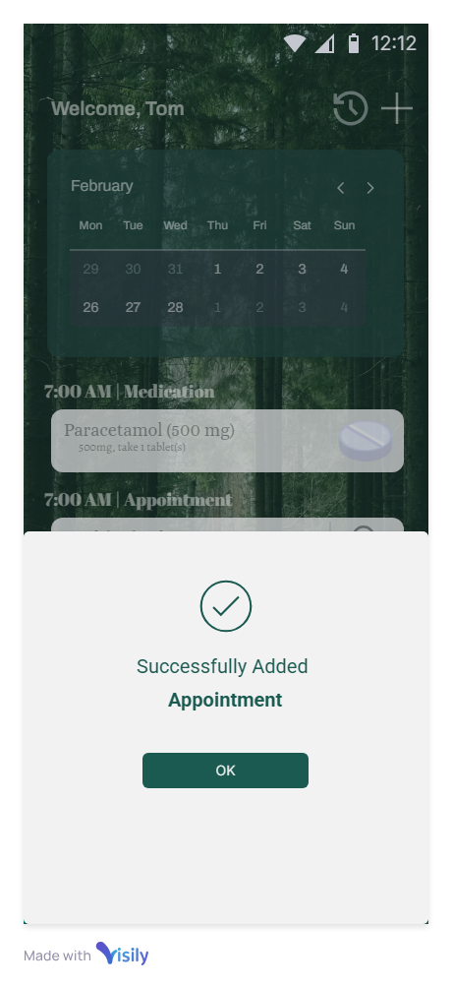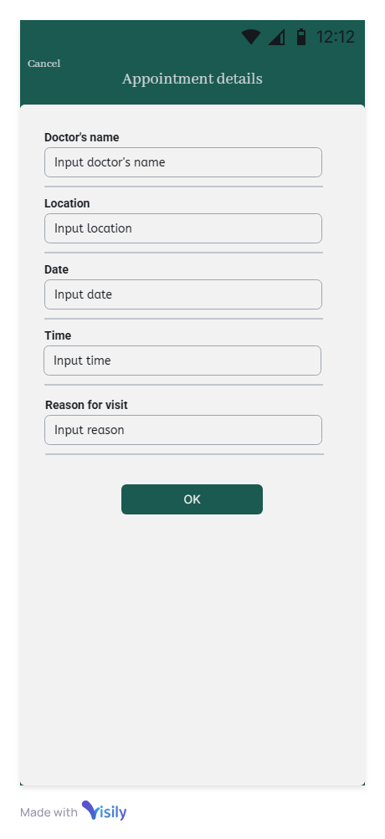

* If the user chooses to add an appointment, the user will be presented with a screen where they can fill in necessary information of the appointment to add.
* After adding all the necessary information, a pop-up screen will inform the user that the appointment has been added.
* **Edit appointment & healthcare reminders:**
* The user will also be able to modify each appointment or healthcare reminder by editing their respective existing information.
* The user can also choose to delete an appointment or healthcare reminder from the list.

1. **Notifications**

* **Notification list:**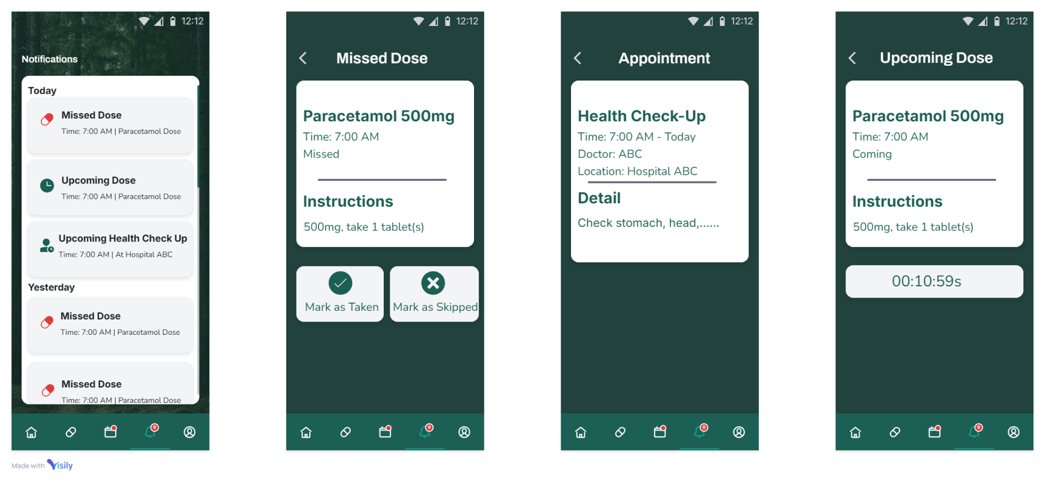
* Upon choosing the bell icon in the bottom tab in the home screen, the user can see a list of reminders for today and some previous days, mainly focused on missed and upcoming reminders.
* The user can choose each individual item in the list to see more information about each respective reminder. If the reminder was missed, the user can choose to mark the reminder again as “Taken” or “Skipped”.

1. **Profile**

* **Profile tab:**

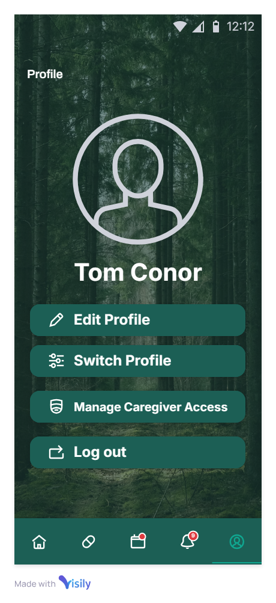

* Upon choosing the profile tab in the bottom tab, the user will be presented with this screen, where the user can choose to edit, switch, manage caregiver access or logout of their profile.
* **Edit profile:**

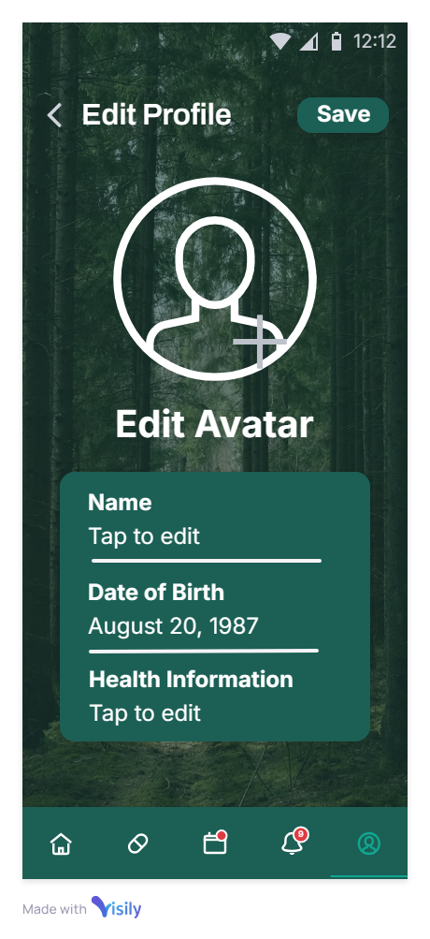

* If the user chooses to edit their profile, the user can change their avatar, name, date of birth and health information.

* **Switch profile:**

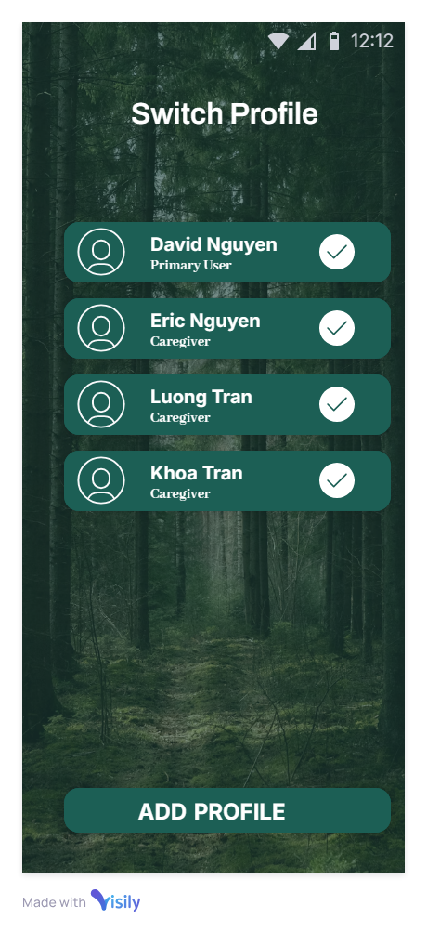

* If the user chooses to switch their profile, the user is presented with a list of their created profiles to switch between.